1. heap sort.cpp (output)

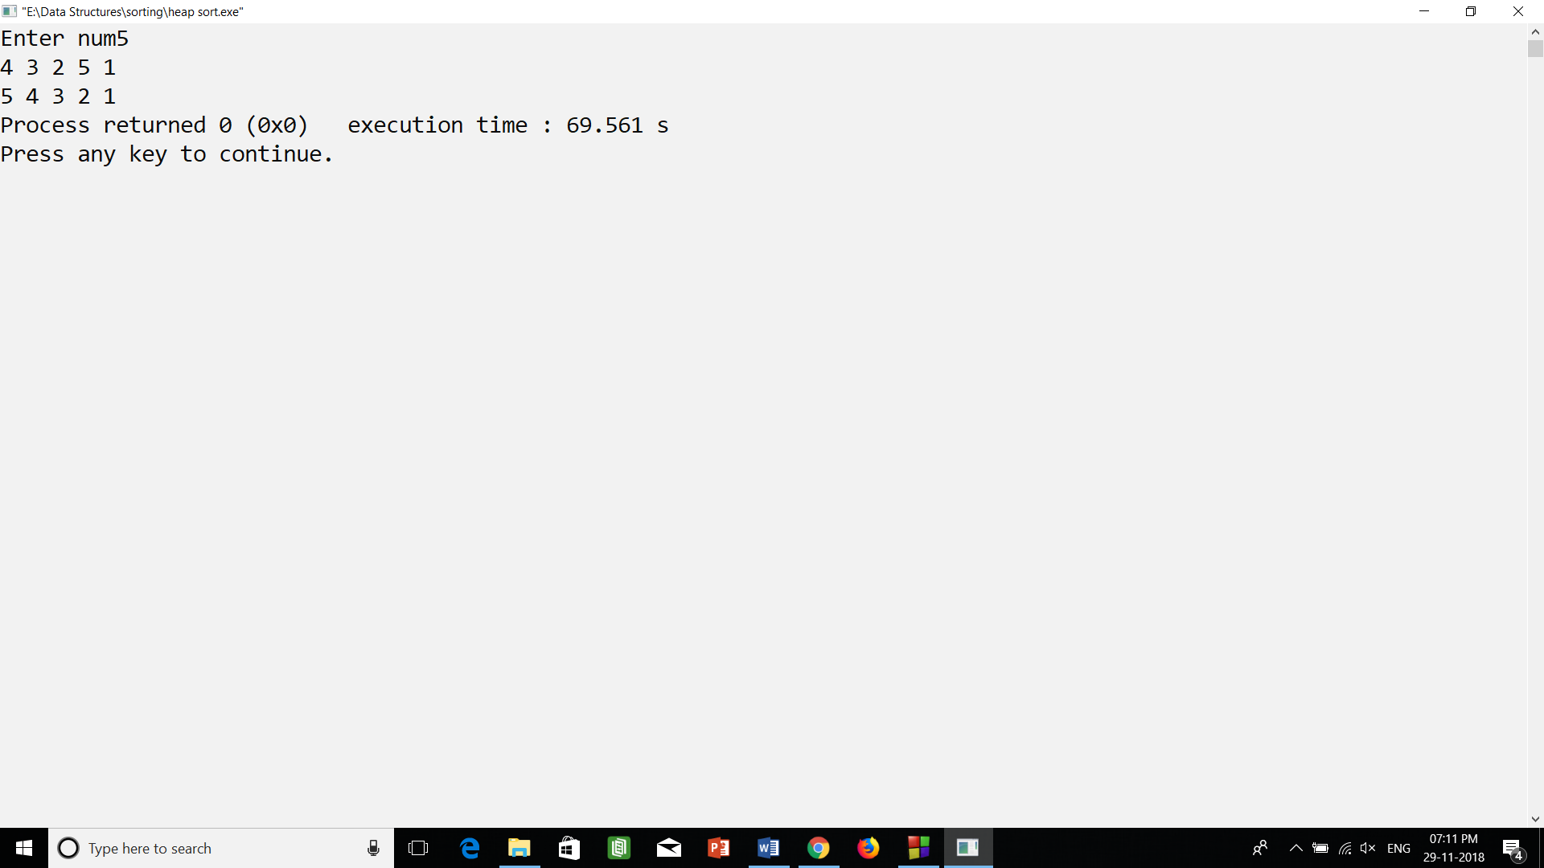

2.) merge sort.cpp (output)

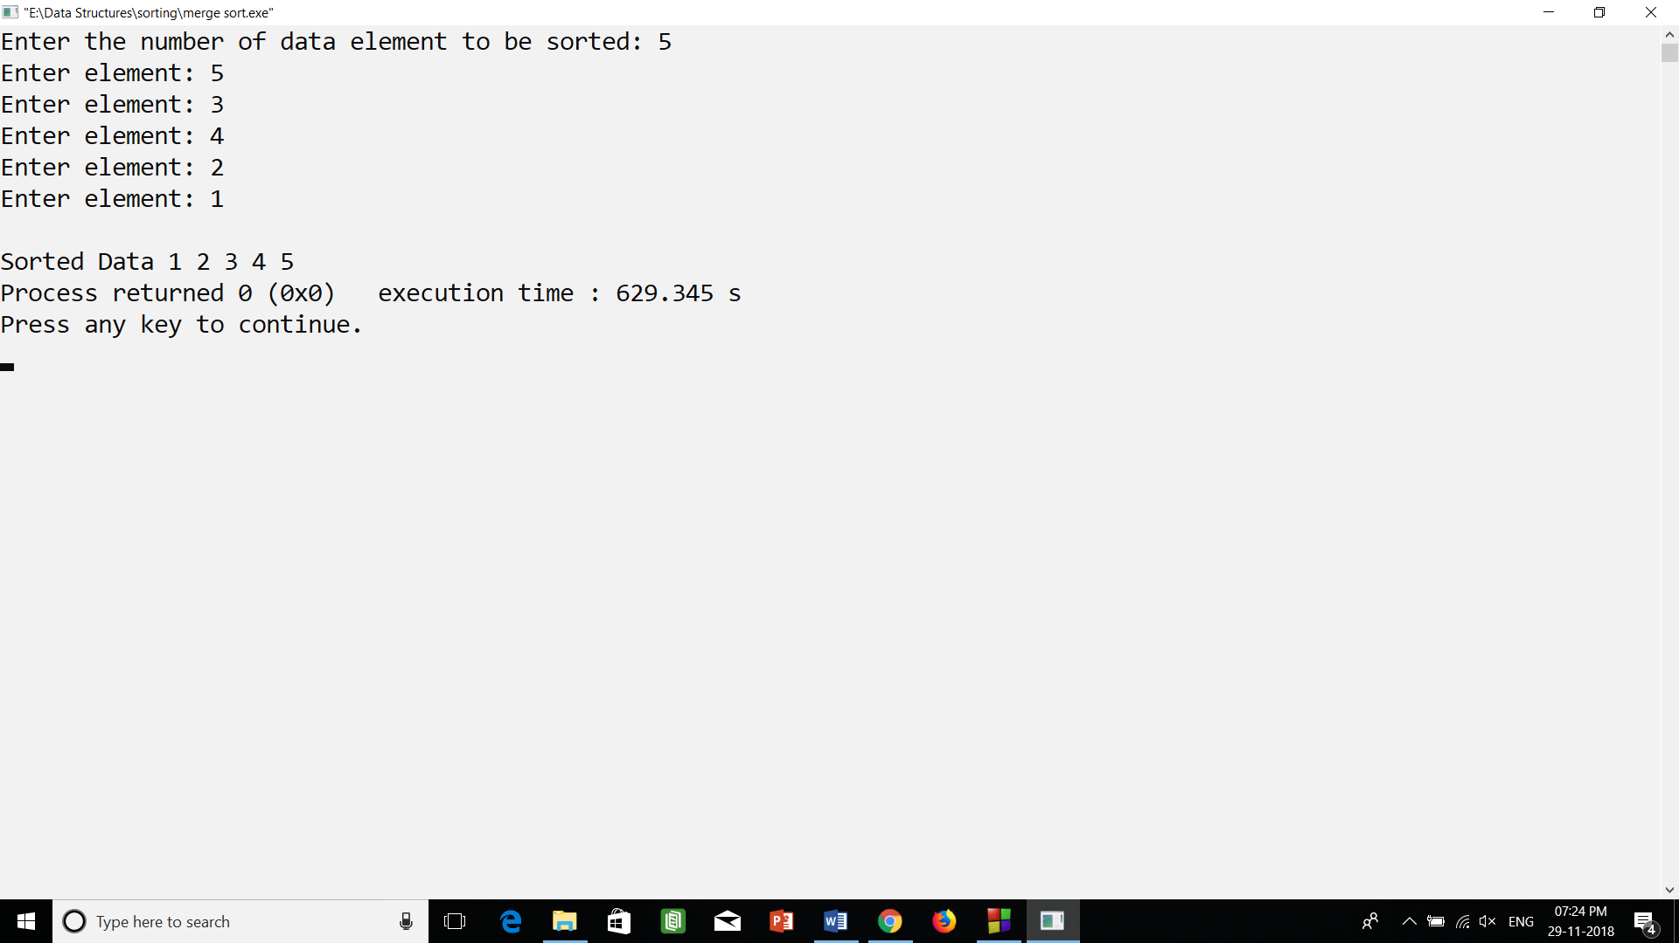

3.) quick sort.cpp (output)

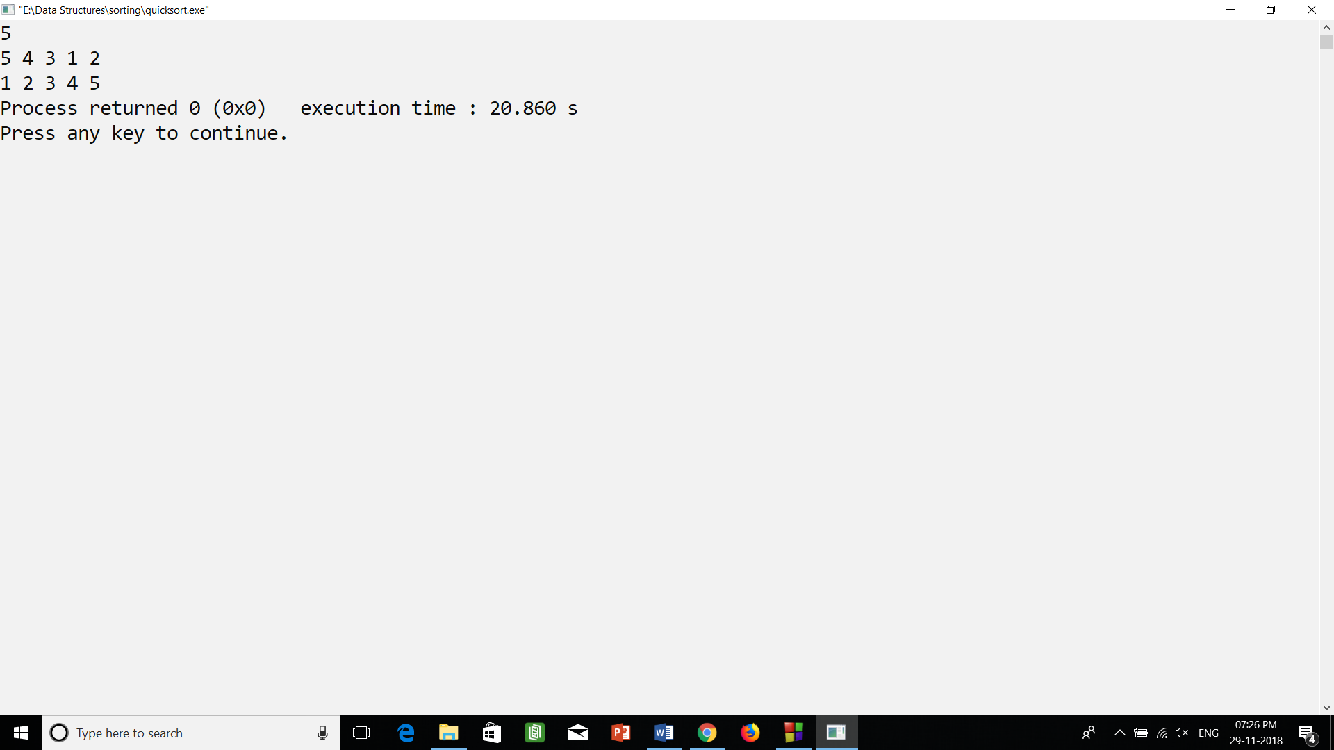

4.) radix sort.cpp (output)

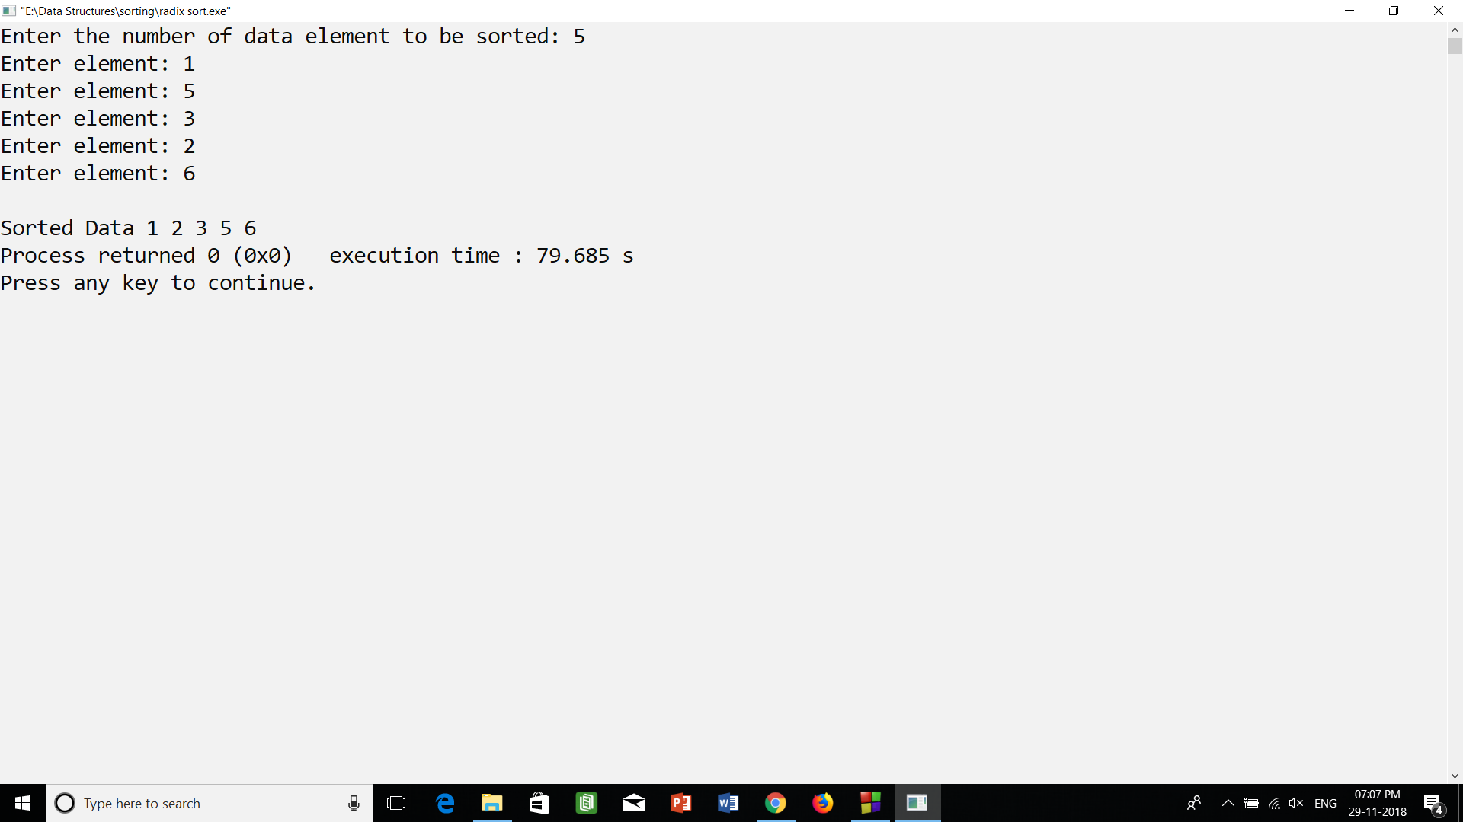

5.) sorting(insertion,selection,insertion).cpp (output)

